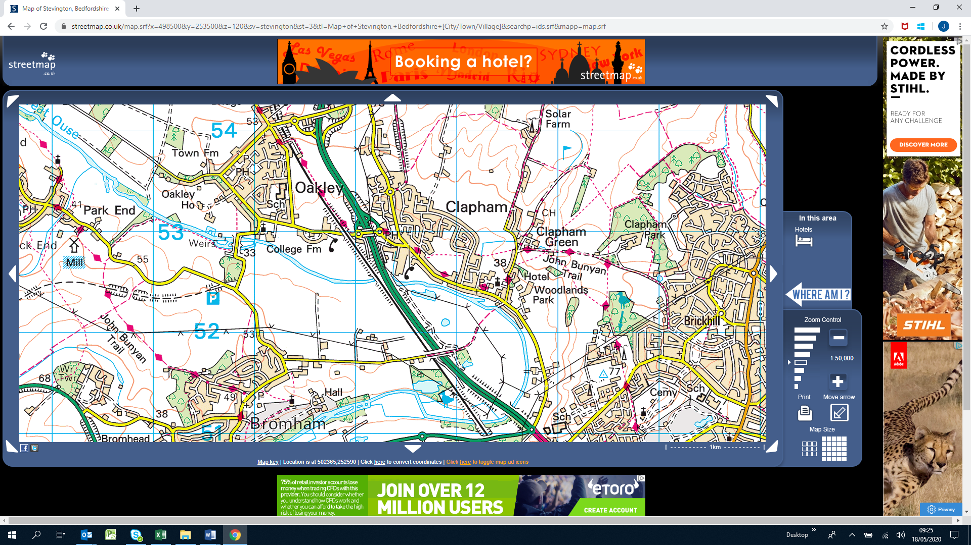

**Oakley Road Overbridge**

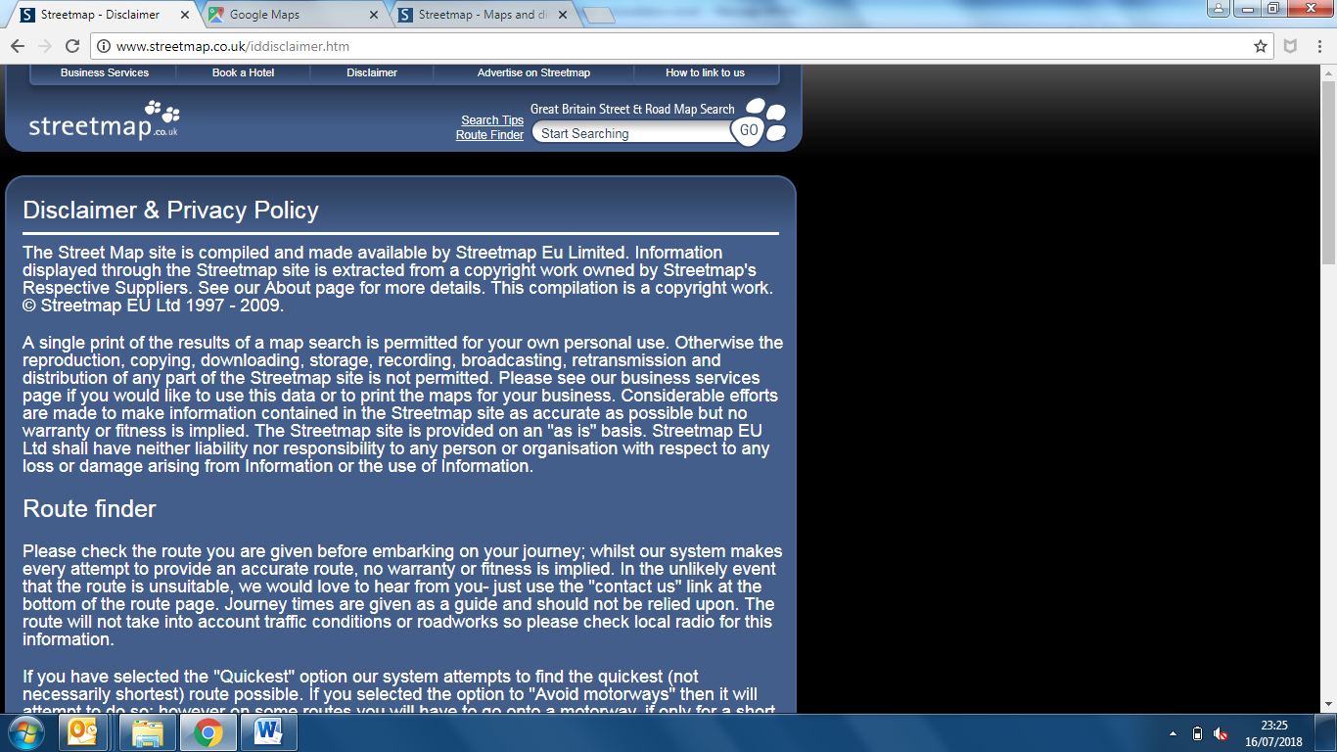

**Oakley Road Overbridge**

**Location Plan**