|  |  |
| --- | --- |
| O | **OAKLEY PARISH COUNCIL**  **31 Radwell Road**  **Milton Ernest**  **Bedford**  **MK44 1SH**  **Tel: 07873 887370**  **Email:** [**parishclerk@oakleyvillage.co.uk**](mailto:maea@paice31.fsnet.co.uk) |

**Strategic planning decisions which could have a major impact on Oakley and the surrounding countryside**

A series of strategic planning decisions have been taken by Government, Bedford Borough Council (BBC) and East West Rail over the past year or so that could have a considerable impact on our village and the north Bedfordshire countryside but which residents may not be aware of. Indeed, Oakley Parish Council has only been made aware of the full extent of them in recent months.

The purpose of this article, which we had hoped to include in the recently distributed Newsletter but unfortunately were unable to meet the print deadline, is to let residents know about these strategic plans and to advise you of the potential impact they could have on our community and the beautiful North Bedfordshire countryside. This is our understanding of the present situation.

**Oxford – Milton Keynes – Bedford – Cambridge Arc development area**

Last year, in March 2019, Bedford Borough Council was party to an agreement with Government committing the Borough Council to the Government’s development proposals for a massive urbanisation of the Oxford–Cambridge Arc, previously recommended by the National Infrastructure Commission.

This Agreement is called “The Joint Declaration” and a copy of it can be found on the Parish Council website [www.oakleyvillage.co.uk](http://www.oakleyvillage.co.uk)

The National Infrastructure Commission has suggested +1 million new homes across the Arc. The Arc is approximately 85 miles long and 1 million homes is equivalent to around 20 cities the size of Cambridge. This number of new homes would encourage a huge population movement into the Arc from elsewhere in the UK, increasing the population of the Arc by approximately +1.9 million people – twice the population of Birmingham. For comparison, the entire county of Oxfordshire currently has less than 300,000 homes.

**East West Rail – Northern Route**

The Borough Council supported the northern route for the Bedford to Cambridge section of the new East West railway. East West Rail published their recommendation of the preferred northern route, Route E (see below) a few months ago. More information is available at <https://communityhub.eastwestrail.co.uk/>



© East West Rail 2020

The exact route is yet to be finalised but it will take the railway through Bedford Station and across the countryside north between Clapham and Brickhill before turning east past Ravensden and Wilden to a yet to be decided new station somewhere between St Neots and Sandy, then on to Cambridge.

This route was supported by the Borough Council as the best option because they considered that new towns previously proposed by developers in the countryside north of Bedford (Twinwoods, Sharnbrook/ Colworth, Wyboston) would be “better served by a northern route”- see Page 8, Para 2.10 to 2.14 of the BBC Response to the East West Rail consultation available on the Oakley Parish Council website.

We understand that a new northern “parkway” station could be built (possibly funded by developers) around Twinwoods to serve these new communities should they go ahead.

The BBC consultation response to East West Rail was not circulated to Parish Councils and has not been published on the BBC website.

The Parish Council is very concerned about the impact of these development proposals on the North Bedfordshire countryside, already subjected to very serious biodiversity loss and also the effect of additional traffic on all the villages right across North Bedfordshire and the beautiful River Great Ouse Valley area.

The Parish Council supported the southern route (Route B) using Wixams as a parkway station to limit traffic entering Bedford Town, improving the quality of life of residents and then following the already established A421 transport corridor to a point for a new station somewhere between St Neots and Sandy. Route B can be seen on page 16 of the East West rail consultation document at

<file:///C:/Users/Oakley%20Parish/Downloads/2019-Consultation-Document.pdf>

**BBC Local Plan 2030 Review “Issues & Options” Consultation**

Following the recent “Issues and Options” Consultation – part of the Borough Council’s Local Plan 2030 Review - the Borough Council has published details of the sites put forward by developers for consideration in the “Call for Sites” see  [bedford.opus4.co.uk/planning/localplan/maps/planning](https://bedford.opus4.co.uk/planning/localplan/maps/planning)

The “Call for Sites” now incorporates the impact of both the Ox–Cam proposals and the decision to take East West Rail north of Bedford.

These sites would be in addition to the already agreed 500 new homes for each of Clapham, Bromham, Sharnbrook and Great Barford – total 2,000 new homes.

Bedford Borough Council have said that they will make a decision regarding which of the proposed developments to take forward by the Spring of 2021 as part of their Local Plan 2030 Review process.

**Below are excerpts from the “Call for Sites” maps:**

This shows the sites (in pink) put forward for the Clapham, Twinwoods, Oakley, Milton Ernest areas. **Around 6,000 new homes at Twinwoods, Clapham.**

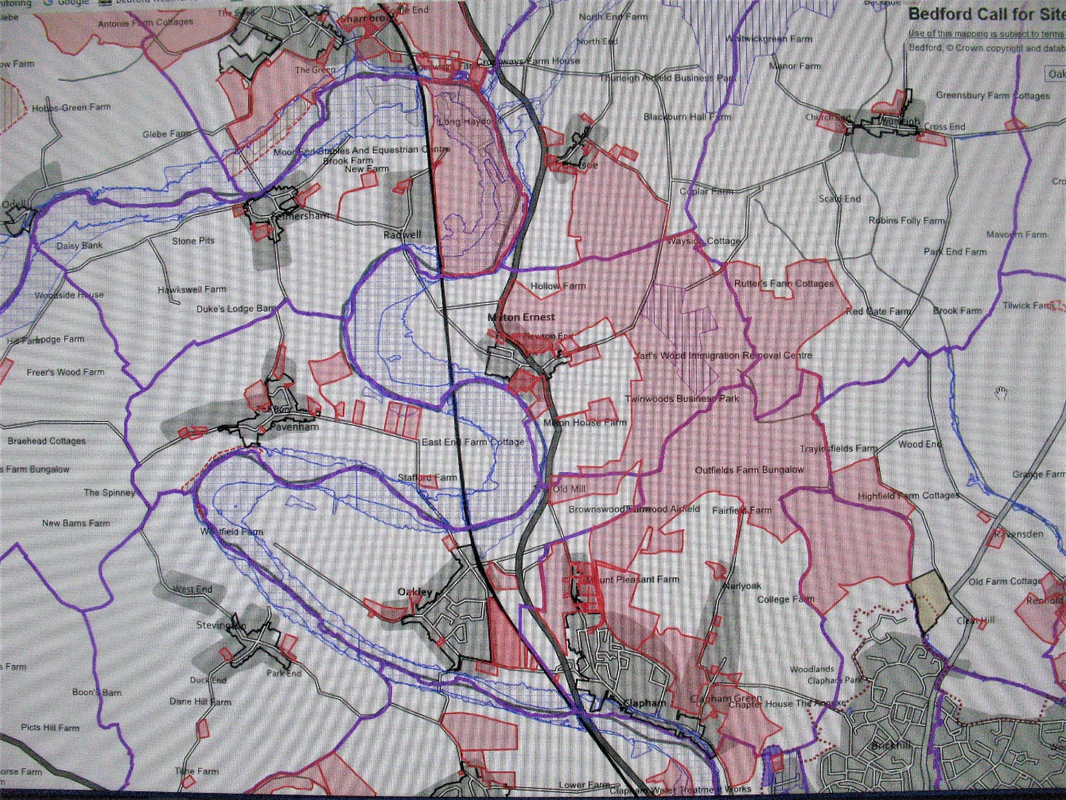

© Bedford Borough Council 2020

This is the map of sites put forward around the Sharnbrook, Colworth, Souldrop, Harrold area:

**Around 4,500 new homes at Sharnbrook/Colworth/Souldrop**

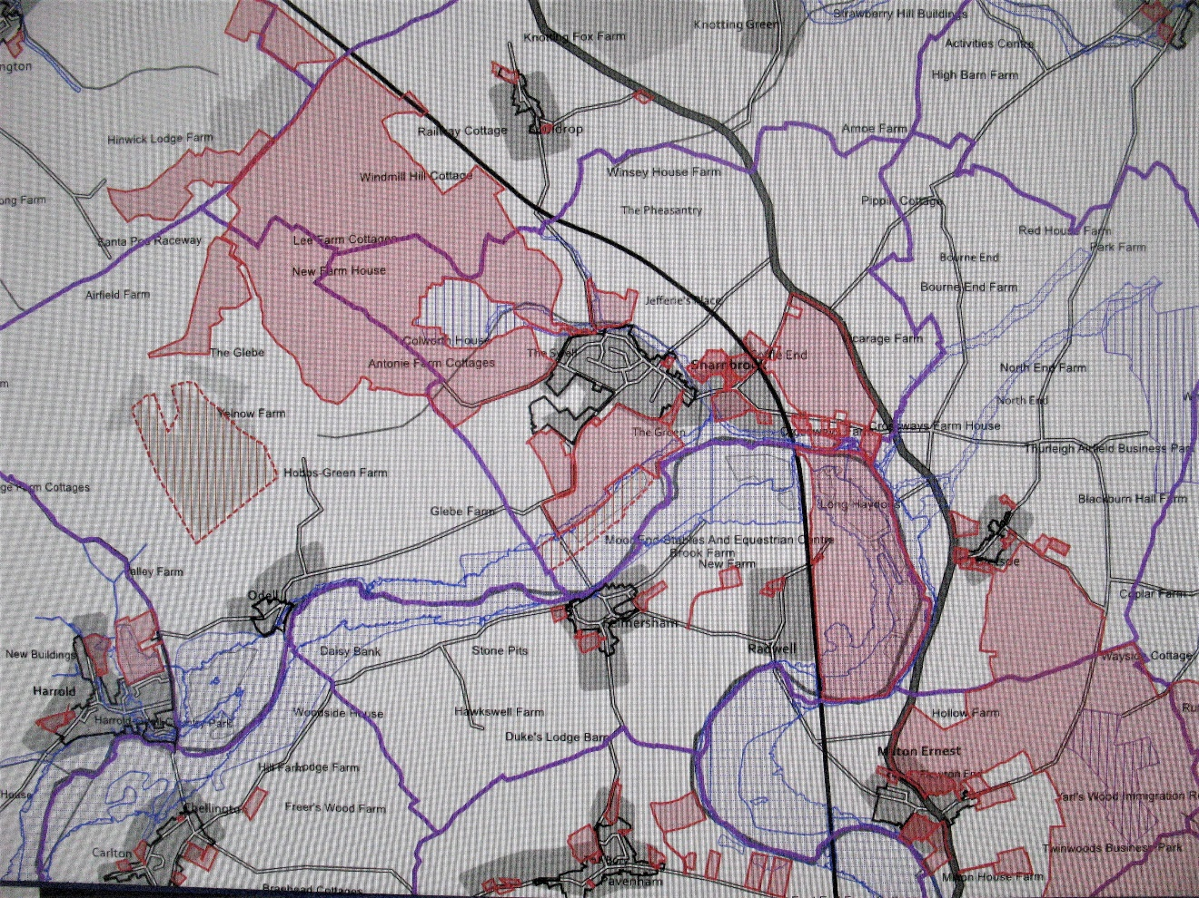

© Bedford Borough Council 2020

**Note:** to judge the scale of these proposed developments, Oakley village has 1,000 homes. The town of Ampthill has approx. 4,000 homes.

The Parish Council is very seriously concerned by these development proposals. We have already met with our MP, Richard Fuller and the Mayor, Dave Hodgson to make them aware of our deep concerns and we are considering what other action we can take, perhaps by joining together with other like-minded Parish Councils in North Bedfordshire to oppose these plans.

**Please let the Parish Council know your views on the impact of these strategic planning decisions. These can also be forwarded to the Mayor (email: dave.hodgson@bedford.gov.uk), your Borough Councillor, Jon Abbott (email:** [**Jon.Abbott@bedford.gov.uk**](mailto:Jon.Abbott@bedford.gov.uk)**) and your MP, Richard Fuller (email: richard.fuller.mp@parliament.uk).**

We will keep you updated through the Parish Council website, the Parish Council Facebook page and our Newsletter.

**Oakley Parish Council – December 2020**