O |  |  |  | OAKLEY PARISH COUNCIL  31 Radwell Road  Milton Ernest  Bedford  MK44 1SH  Tel: 07873 887370  Email: parishclerk@oakleyvillage.co.uk
Our ref: |  | Your ref: |  |  | Date: | 19th September 2019

Ms. W. Burden
Intelligent Plans and Examinations (IPE) Ltd
29 Monmouth Street
Bath
BA1 2DL

Dear Ms. Burden

INDEPENDENT EXAMINATION OF THE OAKLEY NEIGHBOURHOOD PLAN

Thank you for your letter of 27th August. We have considered the points you raised and our comments are set out below.

- Can the QB confirm that the boundary of the ONP follows the Parish Council boundary as shown on the map on page 32?
Yes that is correct.
- The final paragraph of page 10 states that “no new organisations or expansions to existing organisations requiring additional parking should be permitted if they require access in or through the village or are likely to increase the volume of traffic within it”. A statement made within the text of the ONP does not have the status of a policy, but nevertheless it provides an indication of the approach to be taken towards certain types of development. In this case, the form of words is over prescriptive.

The National Planning Policy Framework (NPPF) indicates that there are three overarching objectives to sustainable development which include an economic as well as an environmental objective. To make such a prescriptive statement within the text of the ONP would prejudge a development proposal on the basis of just one of the three objectives without taking into account any benefits which might contribute to economic or social objectives. I would therefore welcome the QB’s comments on the following form of words in substitution for this sentence:

“In considering proposals for new organisations or the expansion of existing organisations which require additional parking and access through the village, the impact of the proposal on traffic congestion and parking will be an important consideration to be weighed against any economic or social benefits.”
Agreed - We will replace the sentence in the text with the examiners statement above. The relevant text in the ONDP is “For that reason, no new organisations or expansions to existing organisations requiring additional parking should be permitted if they require access in and out of the village or are likely to increase the volume of traffic within it.”

3 It is not clear what is intended by the final paragraph of page 11. Can the QB please explain?
Will change to – “The Parish Council will look very closely at any proposed developments in the village and the impact on the sewerage capacity.

- There are a number of pages within the ONP in which sections of the NPPF are recited. It is not necessary to include extracts from the NPPF within a development plan document since it is widely available for the public to access. Can the QB provide any reason why these extracts should not be removed? (These include pages 15-16, 21, 26, 32-33, 39-40, 43).
They were included because we thought they should show that we had fully consulted the NPPF. We will be guided by you if you feel that they should not be included

- For the same reason, it is not necessary to include extracts from the Bedford Borough council’s development plan documents. Is there any reason why these should not be removed? (These include pages 21-22).
Again, as with the NPPF we felt that we should show that we were fully aware of the Bedford Borough Local Plan. We will be guided by you if you feel that they should not be included. Pages 21 and 22 We would like to leave in as they give the rationale for the text and the policy.

- For completeness, you may wish to note that the NPPF published in February 2019 was subject to a discrete update in June 2019 (see ONP page 16 penultimate paragraph).
We will include this update.

- I note that the ONP takes into account the emerging policies of the Bedford Borough Council Local Plan 2030 (BBCLP). Policy 3S indicates that sites should be allocated to accommodate between 25-50 houses in the ONP. Following the hearings sessions in the examination of the BBCLP, the Inspector indicated by letter that Policy 3S should be amended to enable neighbourhood plans to allocate more than 50 houses if local circumstances indicate that this is appropriate. Has the QB considered whether local circumstances in Oakley would be appropriate for the allocation of land to accommodate a higher number of houses? If so, please provide references to evidence which would support the conclusions.
Refer to Oakley Parishes own housing survey and that the Parish Council expects to continue to commission regular updates on the need for future housing of the village. We will use that evidence to update the plan as appropriate. Any future housing would need to consider the implications for traffic through and within the village and the NDP policies.

- Policy 3S states that neighbourhood plans will allocate sites for new housing. ONP Policy HG1, which deals with housing growth in Oakley, deals only with new housing which is not on allocated sites. Whilst there is clear reference in the ONP to the two new housing sites, these need to be formally allocated in an ONP policy. It would seem appropriate to incorporate the allocation of the sites proposed for housing in the ONP within Policy HG1. I suggest changes to the Policy to incorporate the allocation of the two sites; to provide more clarity in the wording of the Policy; and to avoid an approach which would be over prescriptive and in conflict with national policy. I would welcome the views of the QB and of BBC on the following amended Policy.

“ONP HG1: Housing Growth in Oakley

To meet the requirement for new housing within Oakley the following sites are allocated for residential development:

Land at Station Road to accommodate about 30 dwellings (Site 170)
Land to the rear of High Street to accommodate about 10 dwellings (Site 171)
Land at Parrott’s Close to accommodate 10 dwellings (planning consent 2019)

The development of these allocated sites should be carried out in accordance with the Housing Site Design Brief set out in Annex 4.

In addition to the allocated sites, housing development will be supported on sites located within the Settlement Policy Area and where it would not cause harmful impact on the adjoining rural area.

Housing development outside of the settlement policy area will be supported where
it meets the following requirements:
• It would comprise infill development within an existing housing row or cluster and
• It would complement the existing housing and not lead to any harmful change to the
established character of the locality and
• It would result in existing housing or the proposed housing having adequate
garden space to support outdoor seating, drying of clothes, play and other
typical garden uses and
• It would avoid the creation of further linear or ribbon development along
roads in and around the settlement.

Proposals to bring forward sites as an exception to this policy will be dealt with in accordance with the relevant policies of the emerging Bedford Borough Council Local Plan 2030.”
Agree with the new wording stating the sites to be included in the policy. We will amend as set out above to include a third site recently granted planning permission and to clarify that all the requirements need to be met for housing outside the settlement policy area in line with the current Local Plan.

- Reference is made in Policy HG2 to the Government’s March 2015 Technical Housing Standards. In the emerging Local Plan, BBC states (paragraph 10.36) that it has not identified a particular need for the national standard to become a policy requirement in Bedford Borough. Can the QB provide evidence to demonstrate that there is a need for the national standard to be included in the ONP policy?
The Parish Council would like to ensure that the dwellings are fit for purpose today and in the future. Wellbeing for the inhabitants is a concern. We are primarily a village that attracts families and there should be adequate space for them as the individuals grow. We also need to ensure that houses are accessible for some of the residents of our village with specific needs.

- Policy BE1 restricts the ONP to supporting B1 development only on existing business or industrial sites. The reasons given for such a restriction relate to the potential for the generation of heavy traffic. There is no such restriction to B1 development provided in national policy or in the emerging BBSLP Policy 73, which deals with key employment sites. In these circumstances, therefore, the ONP is seeking to impose more onerous requirements in the assessment of employment development than that set out in national and emerging policies. To secure the compliance of Policy BE1 whilst recognising the importance of the highways issues in the consideration of B class proposals I suggest the following form of words on which I would welcome comments from BBC and the QB:

“ONP BE1: Business

Employment development (as defined by Use Class B1, B2 and B8 of the General Development Order) will be supported in the following locations:

• Within the Highfield Park, Willow Vale and Station Road business parks.
• Within existing business or industrial sites.

Providing there is no significant harm to the amenities of nearby residents or to local landscape and rural character; and
Subject to an assessment of the impact of any new employment development on the highway network to demonstrate that the proposals would not result in any unacceptable increase in traffic congestion, noise or vibration and would not cause harm to road safety or the air quality of residents.”
Agree with the new wording and we will ensure that it replaces the policy in the text.

- National and emerging Local Plan policies encourage the identification of locally important green spaces and valued local landscapes by rural communities. Policy ONP LE1 is headed “Significant Landscape Areas”. It needs to be clear that these landscape areas are of local rather than strategic value, and unless the QB wishes to suggest any other form of words this could be achieved through the insertion of the word “locally” before “significant” in the heading and throughout the text of the policy and subsequent supporting text.
Agree and we will ensure that the word locally is put before significant in the heading “ONPLE1 Locally Significant Landscape areas”.

In addition, through the requirement of “must preserve or”, the third paragraph seeks a higher standard of protection than that provided through national policy. This should be changed to “should contribute to and” to have regard to national policy, unless BBC and the QB have any other suggestions to make.
Agree The new sentence to be “ New development within the setting of significant landscape area should contribute to and preserve or enhance that setting”.

- With regard to the map on page 30, can it be amended by the QB to identify the locally significant landscape areas (LSLA) listed in the Policy? The LSLAs may need to be listed by number in Policy LE1 with the numbers then identified on the Map. In addition, to what extent do the arrows shown on this map encroach outside the boundaries of the ONP and is there policy justification for all the “Significant Landscape Views”?
We will give the locally significant areas a number and put that number on the map on page 30. Arrows are within the boundaries of the ONP. The Justification for the views is stated in the Bedford Borough Council Landscape Character Assessment (April 2014) pages 69-73 “3B Oakley-Great Ouse Limestone Valley see Annex 3. In addition, the impact of the proposed development behind 10 – 14a High Street on the view from the permissive path by the river was one of the Inspector’s reasons for refusing the appeal on application 07/00097/FUL.

- Does the QB rely on Policy AD42 of the Bedford Borough Council Allocations and Designations Local Plan (BBCADLP) to justify the ONP Policy LE3? The only local gap identified for Oakley in the BBCADLP is between Oakley and Clapham. What justification is provided for the application of ONP LE3 to the gaps between Oakley and the villages of Bromham, Stevington and Pavenham? Proposals for developments in Bromham were part of the Bedford Borough Call for Sites, extending Bromham village in our direction. Future proposals might come forward within the gap between Oakley and the neighbouring villages of Stevington and Pavenham when the revision of the Bedford Borough Local Plan begins immediately after the emerging Bedford Borough Local Plan is adopted.

In addition, the map which accompanies Policy ONP LE3 shows the arrows which represent areas in which coalescence should be resisted to be outside the boundaries of the ONP. The Neighbourhood Plan policies can only be applied within the boundaries. On the eastern half of Oakley, should the gap be limited to the land east of the railway line and west of the A6 which falls within the boundary of the ONP?
The Local Gap as detailed is in the Bedford Borough Allocation and Designation Plan 2013 and has been saved in the emerging Bedford Borough Local Plan 2030. It is detailed in the Oakley Village section of the Allocation and Development Plan 2021.

- Can the QB provide evidence to support the identification of the three areas to which Policy ONP DH3 is proposed to apply? Would the provisions of Policy 42S in the emerging BBCLP provide adequate protection to non-designated heritage assets?
The Duke of Bedford cottages in the High Street were assessed as being of historical interest but the owners decided that they should not to be listed. The War Memorial is of historical interest as it is a unique design and it is the only one that features the same number of men killed in both wars. Every year there is a parade and a service held at the War Memorial and it has a special place in the village. The Lovell Homes are of historical interest and have an inter-war design that is unique, promoted allotments and a bowling green to provide the inhabitants with a healthy life. Although the Policy 42S in the emerging Local Plan does give protection, the list in the Oakley NDP gives added protection because of the historical importance of those buildings and their setting.

- BBC and the QB are familiar with the criteria which national policy applies in the identification of Local Green Space (LGS). The NPPF sets out the list of criteria for LGS designation in paragraph 100, which states that LGS designation should only be used where the green space is “demonstrably special to a local community” and is “not an extensive tract of land”. Further detailed guidance for the designation of LGS is set out in Planning Practice Guidance (PPG). In these circumstances, careful consideration is required to ensure that LGS designation is justified.
We believe that the sites fulfil one or more of the NPPF criteria of local significance, beauty, historical significance, recreational value, tranquillity including wildlife and is local in character and is within reasonable walking distance of the community it serves. The NPPF/PPG does not define “large tracts of land”. We believe that these are not large tracts of land as they can easily be walked through and around.

Having regard to the NPPF and advice in the PPG, Site 7 is a playing field for Linford Academy. The NPPF at paragraph 97 provides protection from development for playing fields and the PPG states that where land is already protected by a designation, consideration should be given to whether any additional local benefit would be gained by designation as LGS. Can the QB provide reasons why the additional protection as LGS is required?
If ever the school is expanded in the future and the playing field located further up Station Road then this would need LGS designation to preserve the landscape and open rural character of the village along Lovell Road. It is designated as part of the Local Gap between Oakley and Clapham in the Allocations and Designation Local Plan 2013. This was saved in the emerging Local Plan 2030.

Similarly, Site 8 is subject to a TPO. Why is the additional protection of LGS justified here?
The whole spinney is part of the character of that area and is an important contributor to the beauty and tranquillity of Westfield. Road. It supports many species of wildlife.

Sites 9 and 10 comprise substantial areas of land. Does the QB wish to provide any further justification for the designation of these areas?

I will visit each of the sites proposed as LGS and may have further questions to raise following my visit.

Site 9 - the site is on the edge of the village and reflects the rural nature of the area. This is the setting of the historical part of the village. The historical area of the Village is bounded by the grade 1 listed bridges over the River Great Ouse, the site of the Mill as detailed in the Domesday Book, Oakley House and its environs, the Grade 1 listed Church plus the Grade 2 houses by the Church. A footpath from Church Lane runs through the site and it is bounded by The Drive with its many Grade 2 Cottages. The views of the River Great Ouse are very beautiful and include long views to the listed Stevington Mill. Responses to the questionnaire indicated that it is the most important of the ten sites to residents. 83% of those who responded considered it to be important/very important to the local community and 74% saw the open space surrounding the river as special to the local community. The footpath across the field is the access from the village and within the historical area of the village and reflects the rural aspect of the river and the area.

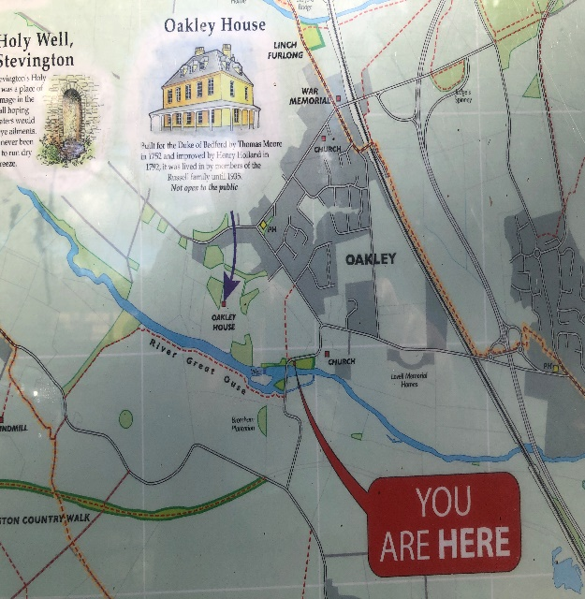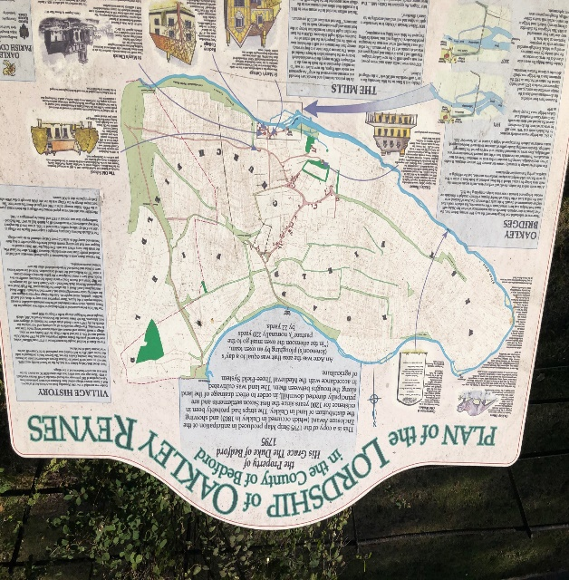

Site 10 - Millennium Wood is an extension of Browns Wood and will enhance and preserve the status of the Local Nature Reserve. Millennium Wood was created to mark the millennium and local people were involved with the planting of the site and have a strong attachment to it. On National Important Days the villages of Clapham, Oakley, Milton Ernest and Pavenham organise a celebration at the wood with the lighting of a beacon. These events are enjoyed many of the villagers. It is a beautiful and tranquil setting on this the highest hill in North Bedfordshire offering extensive views across the River Great Ouse Valley and towards the Greensand Ridge. Many people use the wood for recreation, enjoying the views, the tranquillity, the plants and wildlife. They are local people from, Oakley, Milton Ernest, Clapham, Bedford and from further afield. It is part of a well-used network of footpaths in this area of North Bedfordshire. On the Clapham side of the wood there is a new burial ground for Clapham, which was chosen for the beautiful and tranquil setting.

- Changes to Policy HG1 are suggested to incorporate the allocation of the two residential development sites. With the allocation of the sites within the policy, does the QB consider it necessary to include the section headed “Proposed Development Sites” on pages 50 -51 within the Neighbourhood Plan?
The Parish Council will be happy not to include the introduction. However, they would wish to keep Development Sites selected as it provides the rationale for those sites. It might be more appropriate to include it in the Policy of the sites selected in ONP-HGI. We would like your views on whether it is appropriate to include it here or in the sites selected in ONP-HG1.

- Page 52 deals with changes to the Settlement Policy Area (SPA). Would the QB consider it appropriate to move the whole page forward and insert either before Policy HG1 or immediately after the HG policies on page 20/21?
Agree before ONP HG1.

- Annex 2 lists Village Assets designated by the ONP. Is there any policy in the ONP or in any other development plan document which supports the designation of Village Assets? If there is no policy justification, can the QB provide a purpose of the list?
These were considered very important village assets by the residents and therefore Oakley Parish Council felt that they should list them to recognise their value to the village community.

Is it appropriate to include Milford House and the domestic curtilage within Area 3?
Yes we feel it is because Milford house is in the walled garden of Oakley House and as such is part of the curtilage of that Grade 1 listed house. If not included will not be part of the historical context of that part of the village

- Can the QB confirm if it would be appropriate to include the housing numbers for each of the development sites in Annex 4? In addition, should the briefs include matters such as ecology, surface water, impact on listed buildings, and traffic management measures where these are relevant to each site?
The sites will be amended to state that there will be an ecology, surface water assessment and the details of any mitigation needed. Site 170 will also give details of any impact on the listed building and details of the mitigation needed. 170 and 171 - traffic management measures to include safe crossings of the narrow roads fronting the developments and any other measures Bedford Borough Highway Authority might include when considering the application.
We will add a note to the effect that land at Parrott’s Close has already received planning consent, a zebra crossing has been authorised by Bedford BC and construction is underway.

Yours sincerely

Mrs. A. E. Paice
Clerk to the Council

