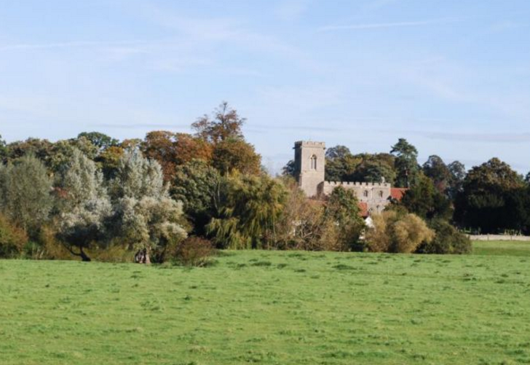
LANDSCAPE & ENVIRONMENT

Policy LE1
Development within Oakley Parish boundary will conform to the development guidelines laid out in the Oakley Village Landscape Character Assessment supported by the Bedford Borough Landscape Character Assessment.

Policy LE2 – The River Valley
The river and river valley area throughout the parish will be protected from development.

Policy LE3 – The Limestone Bridges
3.1 The ‘Two Bridges’ Approach into Oakley from Bromham
No development will be allowed which impinges upon the views between St. Mary’s Church and the Two Bridges to/from Bromham or upon the long views up and down the river from the Bridges as described above.
3.2 The Stafford Bridge
The landscape settings surrounding the Stafford Bridge, including Linch Furlong and the allotments, will be protected from development.

Policy LE4 - Long Views to and from Oakley
Development will not be permitted that will impact upon the Long Views to and from Oakley.

Policy LE5 - Coalescence with Neighbouring Villages
To prevent coalescence with neighbouring village Clapham, no development will be permitted on the area of land east of Station Road opposite the schools, extending from the Old Station in the north, to Lovell Road in the south.

Policy LE6 - Linear Extension of Oakley
The linear extension of Oakley along the entrance roads will be restricted for the reasons identified in the Oakley Village Landscape Character Assessment above.

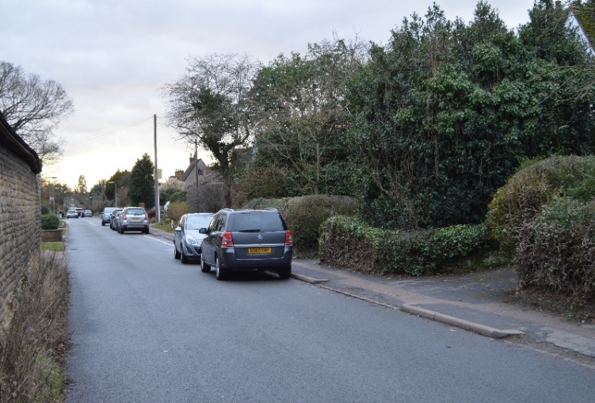
Policy LE7 - Conserve Rural Village Identity

To preserve the rural identity of the village, the following policies will be adopted:

7.1 New development will conform to the local vernacular with respect to boundary identification, i.e. hedges, walls and fencing.

7.2 Future development of the village will incorporate the following:
a) Excessive signage will be avoided,
b) Street lighting will be minimal, sympathetic with the local setting and in line with the village identity,
c) New development will conserve the rural character of the roads in the village.

7.3 The following will be protected:
a) Hedges lining the front gardens on principal roads,
b) The open, semi-rural character of the centre of the village and village green.
c) The semi-wooded areas of the village and the hedges lining the principal access roads.

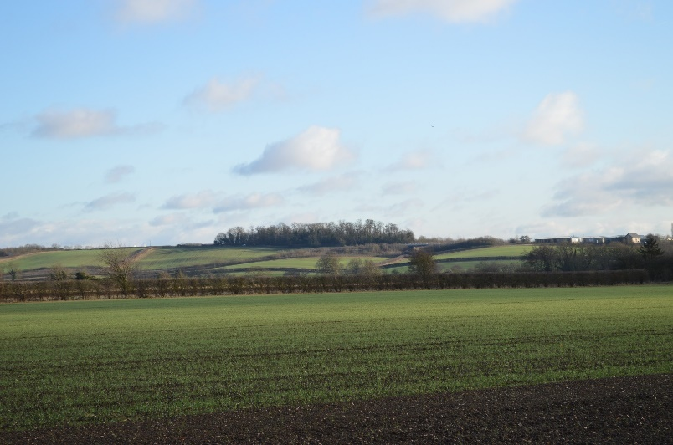
Policy LE8

8.1 No development will be allowed which will damage the woodland areas or the setting of Browns Wood and Judges Spinney.

8.2 No development will be allowed which will damage the long views to or from Browns Wood and Judges Spinney.

