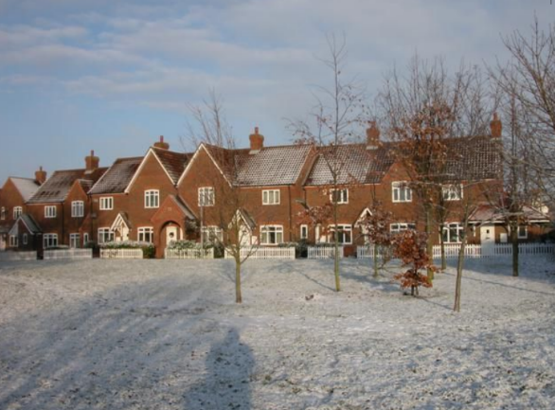
HOUSING GROWTH

Policy HG1
To enable growth within the parish
- Development should prioritise Brownfield Sites first.
- A small development (less than 20 dwellings) or medium development (20 – 40 dwellings) may be allowed in the village envelope.
- A small development adjacent to the village envelope will be allowed as long as the proposals meet the proposals for mixed dwellings based on all the policies in the Plan and is consistent with the existing structure of the village.
Over the last 15 years there has been 10 “windfall single houses”. It is envisaged that this will continue and will be supported as long the proposal meet the all the policies in the plan and is consistent with the existing structure of the village.

Policy HG2
To help identify the appropriate sites for development within the parish
- Development should be on small sites.
- New development should be within or adjacent to the existing settlement area(s)
- Development should prioritise Brownfield Sites first.
- Development should not have a detrimental impact on the open countryside.
- Development should not have a detrimental impact on the views from the entrances and exits to and from Oakley
- Development should not impact on the open spaces separating Oakley from adjacent villages.
- The conversion of existing redundant, empty or derelict buildings to new dwellings would be supported.
- Any proposed development on designated green spaces will not be approved.

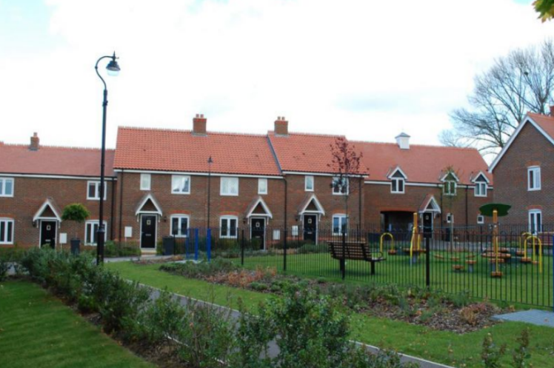

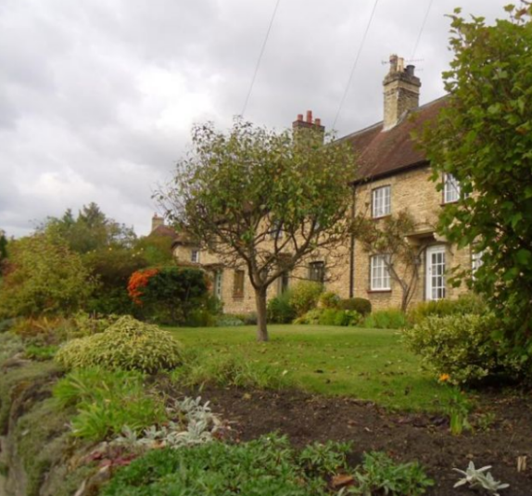
Policy HG3
To help identify the type and scale of development.
- Housing development of 1, 2 or 3 bedroom dwellings will be approved.
- Some single story houses will be approved.
- New dwellings should complement existing building lines, front gardens and hedges where such features are important to the appearance and character of the location.
- Small site developments as in policy 3 must have green spaces and follow the open character of all previous small site developments in the village.
- Site developments or individual houses should be planted with hedging or trees on all the site boundaries to maintain the existing character of the roads in Oakley.

Policy HG4
Ensuring good quality design.
- New developments should integrate with the local surroundings, the landscape and the built environment
- All new housing should use quality materials that complement the existing palette of materials used within the surrounding area.
- Extensions should enhance and be subordinate to the scale of the building in terms of materials, design and structure.
- New developments must have suitable access to the site for people of all abilities.
- Parking must be located so that it does not dominate the street scene.
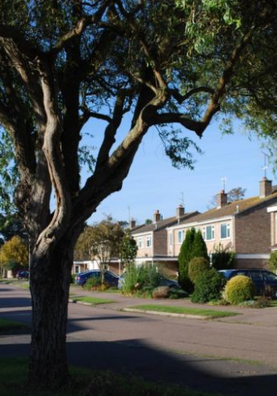
- Garages should be designed to reflect the architectural design of the house they serve.
- Hard surfaced driveways must be of a permeable material.
- Layout of all developments must have adequate footpaths that incorporate safe cycling into and through the site and should allow natural surveillance
- Lighting must be follow the same criteria as the rest of the lighting in the village.
- Layouts of all developments must have a green area.
- Layouts of all developments should follow the open aspects of the other small developments in the village with minimal planting and no fences to the frontages.
- Cycle ports should be integrated into all dwellings
- Bin storage must be integrated into all dwellings.
- All street furniture should reflect other street furniture in the village and should be as minimal as possible.

