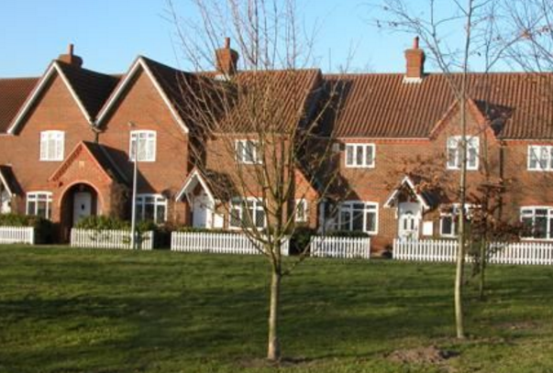
HERITAGE

Policy H1
New development must not impact on the settings, views or access to any of the buildings designated as village assets – see list below
- Development will not be permitted within the area of the Church and the River Bridges.
- Development around Oakley House and the Drive will not be permitted unless it enhances the setting of the Grade II* house and the surrounding landscape.
- The former station should remain a commercial area to retain the industrial and historical heritage of this site
Policy H2
- All village assets that are to be modernised, renovated or altered should be designed with careful regard to the historical structure, architectural interest and setting.
- Any development of a village assets must enhance the historical value of the building.
- Any development of the Duke of Bedford Cottages in Oakley must retain their historical and architectural interest and setting.
- Oakley War Memorial is a unique feature of individual design and must be retained.
- Lovell Homes is a unique example of memorial houses c.1930s and must retain their historical, architectural interest and setting
Village Assets
- Area of College Farm, St Marys Church and Oakley Twin Bridges
- Lovell Homes
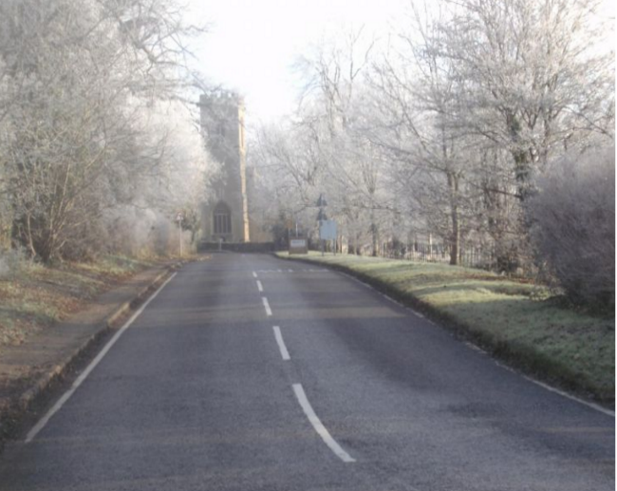
- Area of Oakley House and the Drive
- Wooded character of Church Lane
- Westfield Farm and Westfield Road
- Sports Field and Village Hall
- Duke of Bedford Cottages, High Street
- Methodist Church
- Oakley War Memorial
- Duke of Bedford Cottages, Station Road
- Brockwell and open area
- The open aspect of the 1970s Houses in the core of the village
- The open aspect of Parsonage Close

