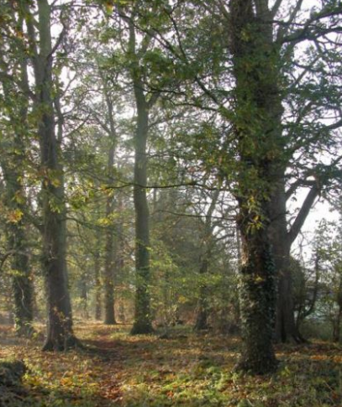
GREEN
SPACES

Policy GS1
Future development should not take place on the Local Green Spaces listed below and identified on Map 3

Policy GS2
Any new development should provide sufficient green spaces, in keeping with the current village design.

Local Green Spaces
- Grange Close Green, bounded by Station Road, Reynes Drive
- Oakley Sports and Social Club, Church Lane
- Linch Furlong Nature Reserve, Pavenham Road
- Land Adjacent to the Great River Ouse, Church Lane
- Judges Spinney, Highfield Road
- Allotments and Community Orchard, Pavenham Road
- Copse/woodland in Westfield Road
- The field to the rear of Church Lane, north of the river
- The field adjacent to houses and schools in Station Road, next to the Midland main line railway and Lincroft New Field
- Browns Wood, Highfield Road
- Paddock and Orchard Associated with Middle Farm, High Street
- Village Green, Reynes Drive

