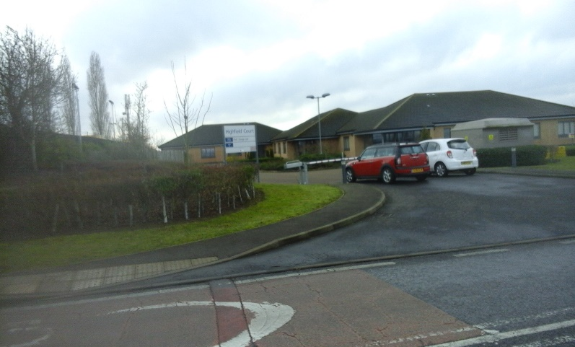
BUSINESS & EMPLOYMENT

Policy BE1
In order to maintain the character of the village we will only support proposals both for new and existing commercial operations within the curtilage of existing commercial premises or former industrial or commercial brownfield sites which do not conflict with other planning policies.

Policy BE2
We will support the development of infrastructure and facilities which encourage the growth of home-based micro businesses.

Policy BE3
In order to limit the flow of large vehicles through the village we will not support any proposals to widen or otherwise upgrade access to industrial sites.

Policy BE4
Any commercial sites which are within 100 metres of areas of high sensitivity to development, as determined by either the Bedford Borough Council or Oakley Landscape Character Assessments, or adjacent to a housing development will be limited to B1 classification.

HIGHWAYS & TRANSPORT
Policy HT1
New development will be approved where there is no significant adverse impact on traffic congestion, on-street parking and road safety.

Policy HT2
New development will keep street lighting to a minimum, sympathetic to the local setting and in line with the local identity. Excessive signage should be avoided.

Policy HT3
New development should provide or improve roads, footpaths and cycleways in the vicinity of the development to ensure safe and environmentally friendly infrastructure.

