Proposed Development Sites

Assessments:
Following initial assessment by Bedford Borough Council a number of sites were considered suitable for further assessment as to their suitability for residential development. Each of the sites has been assessed individually but in the context of
the wider challenges facing the village.

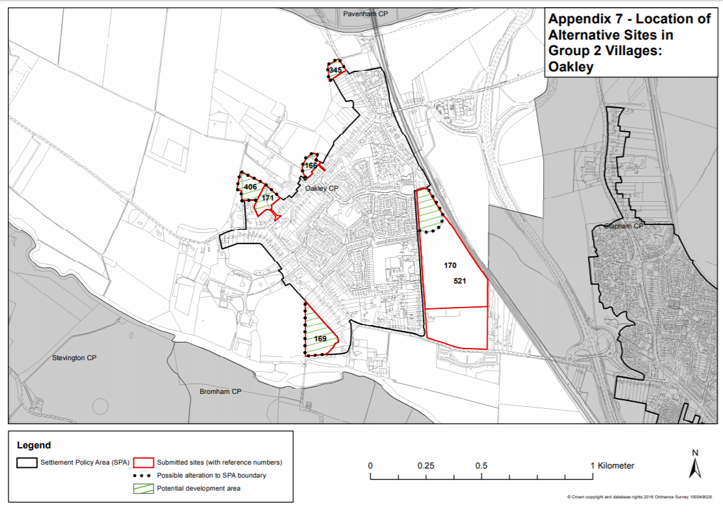
Map showing sites – extract from Bedford Borough Council site assessment document.

A summary of the sites and assessments are shown below.

Site 166 – Rear of High Street: A small site, potentially low density. It would not be an obvious extension to the settlement area. Access to the site would be challenging and there are ecology considerations to consider. Not recommended for further consideration.

Site 169 – Land rear of Church Lane: To many constraints for the site to be developable, including highway issues (pinch point immediately to the south of the site involving Grade I Listed bridge with weight restriction). Part of the site is already a Village Open space and it is proposed under this Neighbourhood Plan to designate the whole site a Local Green Space. Not recommended for further consideration.

Site 170 & 521 – Station Road: A large scale development proposal. The site has highway issues, including traffic relating to the schools. The whole site would be constrained by wider infrastructure issues. However, there could be potential for developing an area at the north end of the site for a small development. Recommended that the developer is approached to discuss a small development option.

Site 171 – Rear of High Street: The site could meet a good part of our housing needs. Would make a logical extension to the settlement area from a spatial perspective. Access has been created, does it meet standards? There are ecology considerations. Recommended for further discussion with developer.

Site 345 – Pavenham Road: A small site, potentially low density. It would not be an obvious extension to the settlement area (would pull it northwards). Ecology and landscape issues to consider. Not recommended for further consideration.

Site 406 – Town Farm: Outside the settlement area. Current access proposals would be very challenging. Ecology considerations. Recommended for further discussion with developer.
More detailed assessment for each site can be found in Urban Vision’s Oakley site assessments report.
Development Sites - Final Assessment & Outcome:
The developers for the three sites recommended for further consideration were invited to present a draft masterplan of their proposal to a joint meeting of members from the Parish Council and Neighbourhood Plan Steering Group. All three developers supplied masterplan information, but only two presented to the meeting.
Following the presentation by developers the full Parish Council, at their meeting on 1st May 2018, considered the three developments as to which site(s) best met Oakley’s needs. The outcome of the review is as follows:
The Parish Council decided that to alleviate additional traffic issues, take account of consultation feedback about small developments and acknowledging the comments made by Urban Vision consultants, that a two-site approach would be taken.

It was therefore agreed that site 171 rear of High Street – up to 20 units and site 170 Station Road (northern part only) – up to 30 units would be their choice of development sites for the Neighbourhood Plan. The development of each site will accord with the Bedford Borough Council (BBC) Highways Assessment and the Habitat Regulation Assessment; which will need to ensure that hydrological impacts are checked and there is adequate mitigation, if required. They will be required to follow the criteria of the BBC Local Plan and the Oakley Neighbourhood Plan policies of Landscape, Green Spaces, Housing and Transport.

The Parish Council and the Neighbourhood Development Plan Steering Group have, by making a balanced assessment of the sites always recognised the impact on individual residents. Their judgement was based on what the residents told us, the planning system from government, the impact on individual residents and the impact on the whole village.
The Parish Council will support these sites, when submitted to Bedford Borough Council to obtain planning permission, subject to the development proposals aligning with the Oakley Neighbourhood Plan and statements made at the presentation on 26th April 2018 being effected.
With regard to the other site considered, site 406 Town Farm. The developer did not present, but the masterplan assumed access via site 171. This proposal was not viable as developers for site 171 were not proposing to incorporate access to site 406. As an alternative access was doubtful, and the Parish Councils approach for two developments in different locations, made this site not a preferred option. It was therefore decided that site 406 would not be supported.

