OAKLEY NEIGHBOURHOOD PLAN POLICIES

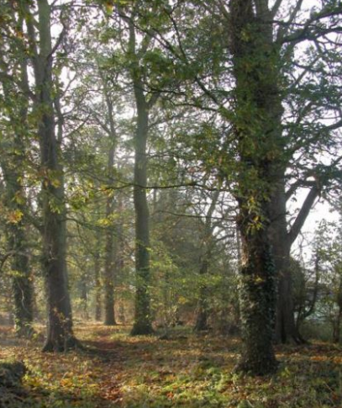
OVERALL GROWTH STRATEGY

The following Neighbourhood Plan Policies seek to ensure that Oakley remains a good place to live and work and is a place of opportunity where everybody can realise their full potential.
Oakley should remain a place where people feel connected with the village and are proud to celebrate its rich natural and built environment, diversity, and history. There needs to be a balance between enabling growth to meet local need and protecting important natural and built environments.
We want to improve the quality of life of present and future generations. The policies should help facilitate the development of housing, micro-businesses and the infrastructure they rely on.
The overall growth strategy is based on identifying the most sustainable areas where housing and business development can be located, whilst also protecting sensitive landscape and preventing uncontrolled development of the rural area. The Oakley settlement boundary is enlarged by this neighbourhood plan to accommodate housing growth, to meet local need.
To make Oakley more sustainable, links to other areas need to be improved. This goes beyond the scope of the neighbourhood plan policies for the most part, but there is also an emphasis on balanced transport provision within Oakley itself.
The policies help to maintain the distinct, separate and rural identity of the village. In particular, policies seek to avoid coalescence between settlements. Local Green Spaces are protected, which provide village residents with much appreciated places for relaxation and recreation, as well as areas of biodiversity, natural beauty and historic value.

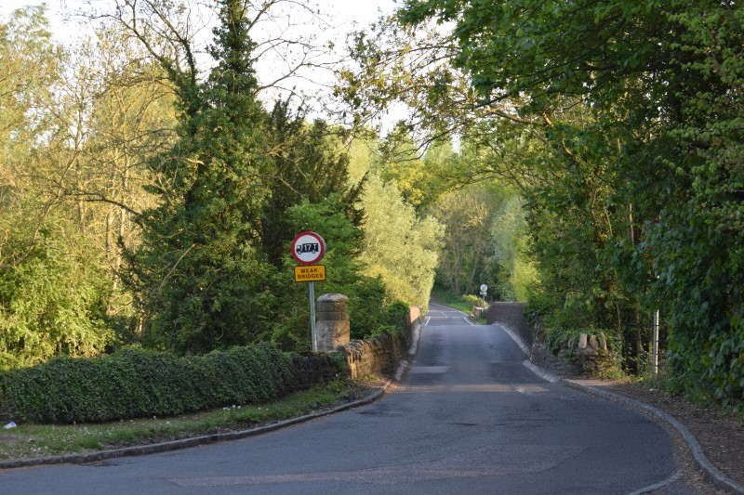
The Bedford Borough Landscape Character Assessment published in May 2014 states that ‘The overall landscape strategy for the Oakley – Great Ouse Limestone Valley character area is to conserve the historic limestone villages, the riverside features such as stone bridges and mills and the tranquil river corridor flanked by woodland belts … Elements to be
enhanced would be the field boundaries …...., the management/restoration of the riverside pastures/grassland ..., and the integration of recent development with the surrounding rural landscape...’.
These aims have been translated into policy. In preparing the policies of this neighbourhood plan, the requirements of the Basic Conditions have been met, including the need for them to be evidence-based. The following documents have formed part of the evidence base for policies:
- Core Strategy and Rural Issues Plan, April 2008;
- Allocation and Designations Plan, July 2013;
- Bedford Borough Landscape Character Assessment, April 2014;
- Landscape Character Area 2A Hinwick Wooded Wolds;
- Bedford Borough Council Adopted Standards for Sustainable Communities;
- Bedford Borough Council Local Flood Risk Management Strategy November 2015;
- Emerging Bedford Borough Council Local Plan 2035 and its evidence base;
- Oakley Landscape Character Assessment;
- Oakley Neighbourhood Plan Road Study 2016;
- Bedford Rural Communities Charity Housing Survey for Oakley, 2016;
- Bedford Borough Housing Strategy 2012-2020 and reviewed 2016 – 2020;
- Bedford Borough Housing Market Assessment;
- Bedford Borough Data analysis of the census 2013;

The following pages contain the policies that will deliver sustainable development and growth in Oakley.

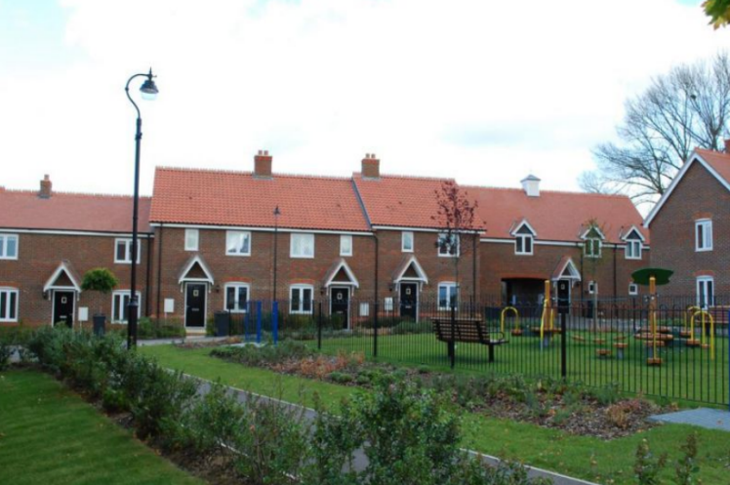

HOUSING
POLICIES

ONP HG1: Housing Growth in Oakley
Housing development will be considered for approval where it involves development of sites within the Settlement Boundary and where it does not encroach into the rural area outside of the Settlement Boundary.
Housing development outside of the settlement boundary will be considered for approval, where it meets the following requirements:
- It comprises infill development within an existing housing row or cluster;
- It would complement the existing housing and not lead to excessive urbanisation or harm to the rural character of the area.
- It would not result in existing housing or the proposed housing having inadequate garden space, in terms of both amenity and local character;
- It would avoid the creation of further linear or ribbon development along roads in and around the settlement.

Interpretation
This policy focuses housing growth in and around the existing main settlement in Oakley (within the Settlement Boundary). The policies prevent housing development in the wider rural area, where it would harm the character and sustainability of the settlement. Infill housing is allowed outside of the settlement boundary, subject to the sustainability texts set out in the policy. The issue of loss of garden space would involve consideration of both amenity (area of garden space) and character (avoiding cramming).

The policy does not deal with exception sites. There is no intention to modify Local Plan policies on exception housing.

ONP HG2: Housing Mix
Housing developments of 5 houses or more must include a balanced mix of house types to meet local need. The mix of housing should include 1 and 2-bedroom housing to meet the needs of first time buyers and those wishing to downsize. This includes at least one house of 1 or 2 bedrooms per 5 houses.

Developers must justify the mix of housing in any planning application, based on evidence of local housing need.
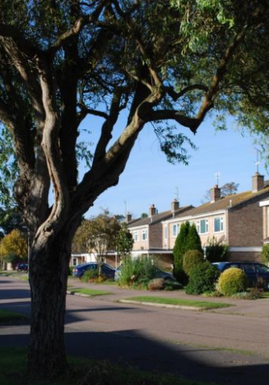

Interpretation
Developers will need to provide evidence of local need to support planning applications, demonstrating that the mix of house types addresses local need.

In considering housing mix, the requirements for room sizes and storage are set out in the Government’s Technical housing standards – nationally described space standard, March 2015 (or any equivalent standard superseding and replacing that document).

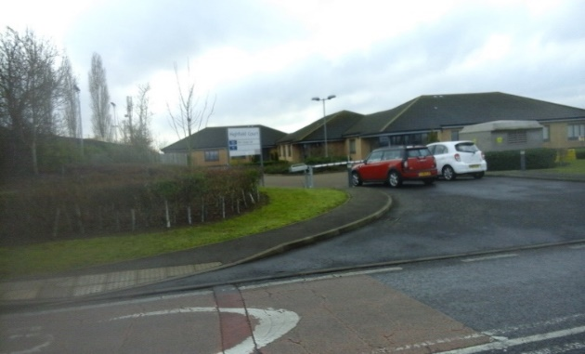
BUSINESS &
EMPLOYMENT
POLICIES

ONP BE1: Business

Business (B1) development will be considered for approval in the following locations:
- within the Highfield Park, Willow Vale and Station Road business parks.
- within existing business or industrial sites, providing there is no significant harm to the amenities of nearby residents or to the local landscape and rural character.

Interpretation
This policy enables B1 development. It does not enable B2, B8 or other higher impact forms of business and industrial development. Whilst applications for such uses would be considered on their merits, the deficiencies in the highway network severely limit the scope for approval. A particular issue in the area is heavy traffic, so regard would need to be made to any likely additional traffic generation, especially involving heavy vehicles.
The sensitivities of the area’s natural and built environment and need to protect the amenities of residents are further factors, likely to be problematical for B2 or B8 uses.
Harm to amenity could include impact of noise, disturbance, dust, smell, vibration, visual intrusion and other factors.
ONP BE2: Retail and Community Facilities
New retail and professional services (A1, A2) and other community facilities will be considered for approval within the existing centre of Oakley, where there would be no significant harm to the amenities of nearby residents.

Interpretation
The policy enables A1 and A2 uses, where they are of a scale and nature that would complement existing facilities. The intention is to allow local facilities in the interests of making Oakley a more sustainable settlement.
Harm to amenity could include impact of noise, disturbance, additional traffic movement, smells and other factors.
ONP BE3: Public Houses
Development proposals involving the use and development of existing public houses will be considered for approval, providing:
- the use as a public house continues as part of the scheme;
- there is no significant adverse impact on the amenities of any nearby residential properties.

Interpretation
This policy allows the public house (or public houses, if more are developed within the plan period) to expand, subject to amenity considerations. It also allows pubs to diversify to include other uses, but at the same time ensures that the core use as a public house is not lost.

ONP BE4: Broadband Connectivity
New development, including new housing and commercial schemes, must incorporate High-speed Internet connectivity and not impact negatively on the functionality of the existing telecommunications infrastructure.

Interpretation
The purpose of Policy BG3 is to ensure new development is ready for connection to faster services. This promotes sustainable live/work patterns by enabling home working and supporting local business.
High speed is defined by the government’s Broad Band UK office as service that offers speeds of greater than 24 Megabits per second (i.e. 24Mbps+, or 25Mbps).
Developers should work with providers of telecommunication infrastructure to deliver the necessary physical infrastructure to accommodate information and digital communications networks as an integral part of all appropriate new developments. A connectivity statement should be included with relevant planning applications to demonstrate that broadband access and speed will be sufficient.

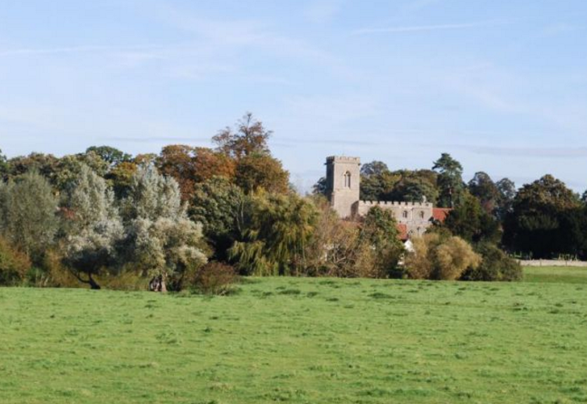
LANDSCAPE &
ENVIRONMENT
POLICIES

ONP LE1: Sensitive Landscapes
New development must not impinge on significant landscape areas.

To be considered for approval, new development adjacent to significant landscape areas must not cause harm, including to hedgerows and hedgerow trees, ecology, flora and fauna, wildlife or views through open landscape.
New development within the setting of significant landscape area must preserve or enhance this setting.

For the purposes of this policy, significant landscape areas are:

- The River Ouse and River Valley area;
- the woodland areas Browns Wood and Judges Spinney;
- the area surrounding Stafford Bridge including Linch Furlong and the allotments;
- The Limestone Bridges and surrounding area.

Interpretation
The policy is part of the wider sustainable growth strategy for the area, highlighting areas where the open character and quality of landscape must be preserved.
The significant landscape areas must remain as open landscape. However, the policy recognises that develeopment ourside of but within the setting of these defined areas must also be given careful consideration in terms of environmental impacts.

Whilst Policies ONP HG1, ONP BE1 and ONP BE2 set the general growth strategy, ONP LE1 introduces explicit environmental considerations for the area’s most sensitive landscapes.

ONP LE2: Local Green Space

Designated Local Green Space must remain as open green spaces. Small-scale built development may be allowed, providing:
- The open and green character of the space is maintained and not compromised;
- The new development comprises facilities to support the community use of space.
- The community, wildlife, amenity and other values as a Local Green Space are preserved or enhanced.

Interpretation
This policy protects the open character and community value of Local Green Space but does allow specific kinds of small-scale development. Examples of small-scale development that could be allowed include:

- A sports pavilion, to support the use of sports pitches;
- Storage facilities for tools and equipment used for maintaining green space;
- A small refreshment kiosk to support the recreational use of space.

ONP LE3 Coalescence with Neighbouring Villages

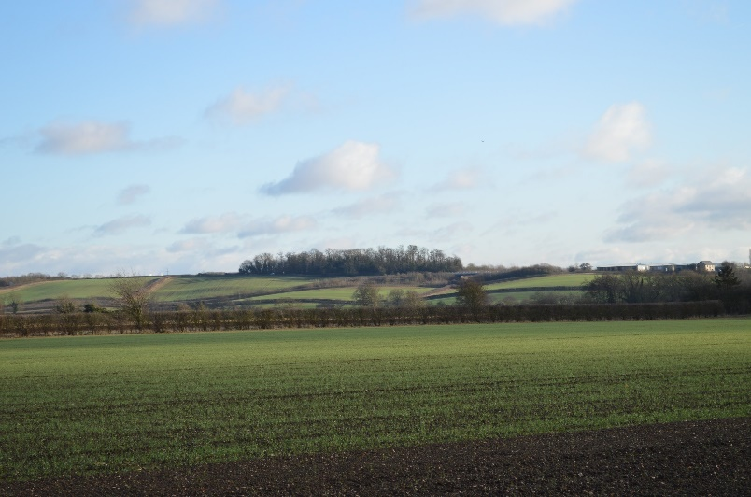
New development must not compromise the open character of landscape that provides separation between Oakley Village and Villages of Clapham, Bromham Pavenham and Stevington.

Interpretation
This policy ensures that the open landscapes between Oakley and Clapham, Bromham, Pavenham and Stevington are maintained. Whilst Policies ONP HG1, ONP BE1 and ONP BE2 set the general growth strategy, ONP LE3 places additional emphasis on the need to avoid urbanisation of the area separating Oakley Village and the other nearby villages.

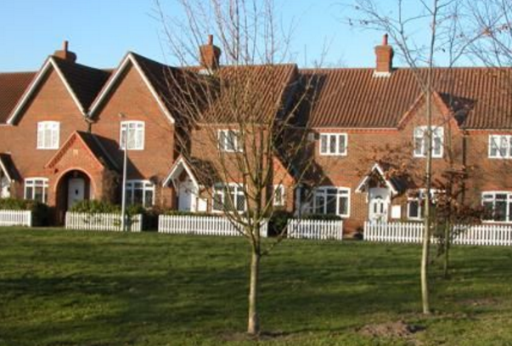
DESIGN &
HERITAGE
POLICIES

ONP DH1: Design
New development should incorporate sustainable urban design. This includes:
- Complementing and integrating with the local surroundings in terms of scale, height, massing, spacing, urban grain and set-back from street frontages;
- designing parking as an integral part of layout, so that it does not dominate the street scene;
- providing active frontages to streets and public spaces, to provide natural surveillance;
- creating attractive, safe, permeable and convenient pedestrian environments;
- providing screened bin storage, away from road frontages;
- using permeable materials for hard surfaces.

Interpretation
Policy ONP DH1 is concerned with sustainable urban design principles. It seeks to promote sustainability by addressing character, local distinctiveness, amenity, safety, and pedestrian convenience. Analysis of the site and context is an essential part of the design process.
The policy applies to all scales of development, though a proportionate approach is necessary and requirements referring to layout would only apply to development that incorporated new layout.
Active frontages refers to elevations containing windows and doors, so that streets and spaces are overlooked.
Car parking should comprise a mix of garages, driveway space, on-street and other provision. This helps to ensure that the public realm is not dominated by parking.
Separation of public and private space involves layouts where rear gardens are located away from road frontages. This avoids the need for high fencing or walls next to roads, which would create a poor quality public realm.

Design and access statement should make clear how the requirements of this and the following policy have been met.

Planning applications should make clear how NPPF’s policy for community engagement has been met, recognising that this is a material consideration. Community engagement should be focused on the pre-design stage, so that the community’s knowledge informs the design process. Late stage engagement, focused on narrow and subjective aesthetic matters, offers little opportunity to influence the fundamental characteristics of a scheme.

ONP DH2: Local Character
New development must complement the existing character of the village. This includes:
- Comprising site specific design to complement the character of the village, rather than generic design solutions that fail to respond to local character;
- Using high quality and authentic materials to complement the existing palette of materials used in the surrounding area;
- Retaining existing front hedges and trees;
- Designing other boundary treatments to complement the established local character through the use of hedges and limestone walls;
- Ensuring development fronting the village green maintains the open character based on front gardens with minimal planting and no fences to the frontages;
- Designing extensions to historic buildings to be subordinate to the scale of the original building, whilst complementing the building in terms of quality of materials and finishes.
Creative, carefully designed, contemporary design solutions are particularly encouraged.

Interpretation
Policy ONP DH2 deals with local character. The policy is not intended to require stylistic imitation or to stifle creativity. Indeed, imitation can be harmful, particularly in historic locations, where authenticity is important. The policy seeks to ensure that development is specific to the site and context.
The term 'high quality materials' includes authentic local materials and other materials with a high standard of finish and durability. The policy would not be met by imitation traditional materials, such as plastic imitation ‘timber’ features.
Creative and innovative design solutions are especially encouraged, in particular designs that incorporate low or zero carbon use.
The use of capable and skilled professional teams is strongly encouraged to meet the standards of design required by Policies ONP DH1, ONP DH2 and other policies in this plan.

ONP DH3: Local Heritage
New development must preserve or enhance the architectural or historic character of non-designated local heritage and its setting. The non-designated local heritage to which this policy relates is:
- The Duke of Bedford Cottages in High Street and Station Road;
- Oakley War Memorial, junction of High Street and Station Road;
- Lovell Homes inter-war memorial houses in Lovell Road.
Interpretation
This policy identifies local heritage that is neither listed nor in a conservation area. Alterations to these structures should be designed to complement the architectural and historic character and setting, which should be analysed and understood as part of the design process.
Policies ONP DH1 and ONP DH2 apply across the neighbourhood area but are especially relevant to application of this policy.
Village Assets
- Area of College Farm, St Marys Church and Oakley Twin Bridges
- Lovell Homes
- Area of Oakley House and the Drive
- Wooded character of Church Lane
- Westfield Farm and Westfield Road
- Sports Field and Village Hall
- Duke of Bedford Cottages, High Street
- Methodist Church
- Oakley War Memorial
- Duke of Bedford Cottages, Station Road
- Brockwell and open area
- The open aspect of the 1970s Houses in the core of the village
- The open aspect of Parsonage Close
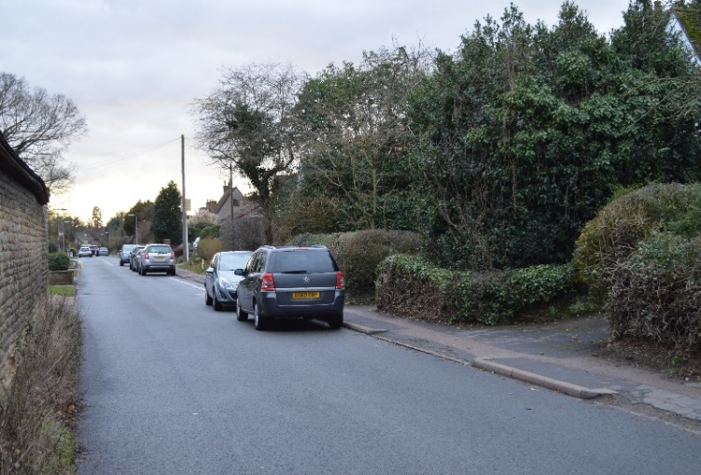
TRANSPORT
POLICIES

ONP TR1: Balanced Transport Provision

New development must contribute to a balanced transport provision, including:
- giving priority to the needs and convenience of pedestrians and cyclists in the layout of new roads and paths;
- providing secure, weatherproof and convenient facilities for storage of cycles.

Attention will be paid to impacts of development on road capacity, congestion and safety, in particular avoiding adverse impacts on:
- narrow roads;
- roads with only one footway;
- roads around the school and post-office.

The contribution of the network of narrower roads to the character of Oakley must be considered. Highway expansion to increase capacity and accommodate development must only take place where it would not cause significant harm to the character of Oakley.

Interpretation
The policy seeks to ensure that a range of transport options is provided, rather than over-reliance on motor vehicles.

The limitations of the local highway network are recognised by the policy, especially the preponderance of narrow roads, some without footpaths on one or both sides.

Whilst such limitations affect capacity, they are also part of the character of the area, and this character could be harmed by insensitive highway works. The policy requires a balanced approach, recognising the importance of conserving character.

