Housing Growth
Policy | Agree | Disagree | Comments
HG1
HG2
Business and Employment
Policy | Agree | Disagree | Comments
BE1
BE2
BE3
BE4
Landscape and Environment
Policy | Agree | Disagree | Comments
LE1
LE2
LE3
Design and Heritage
Policy | Agree | Disagree | Comments
DH1
DH2
DH3

Transport
Policy | Agree | Disagree | Comments
TR1

Green Spaces
Site | Agree | Disagree | Comments
Site 144:
Browns Wood/ Millennium Wood,
Milton Road
Site 147: Woodland Westfield Road
Site 152: Oakley Academy Playing Field,
Station Road
Site 154: Grange Close/ Station Road
Site 155: Land North of the River
Development Site
Site | Agree | Disagree | Comments
Site

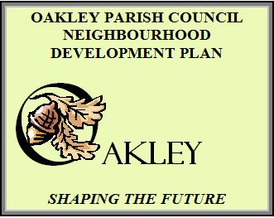
13th May 2018
EXHIBITION FEEDBACK FORM
Please tick the appropriate columns to record your views on the proposed policies, green spaces and development sites.
Please email the completed form to parishclerk@oakleyvillage.co.uk or put in the box at the Post Office by Sunday 20th May. A copy of all the supporting documents can be found at http://oakleyvillage.co.uk/ndp
Thank you for taking part – your views are very important for the future of Oakley.
Please provide your postcode so we know in which area of the village you live
MK43………………………..

